Homeostasis
For the following homeostatic mechanism, identify the various parts.

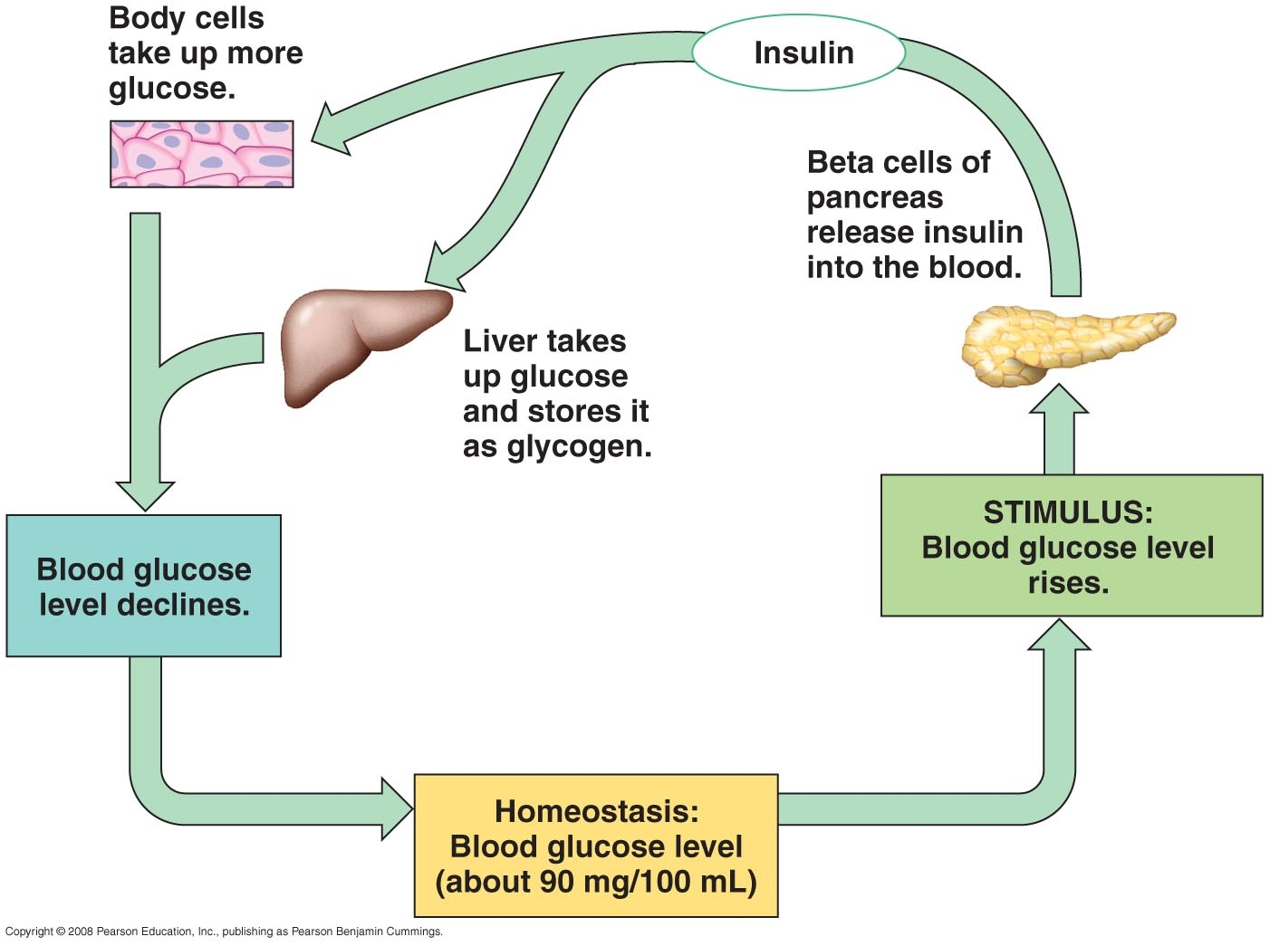

Set Point
Stimulus
Receptor
Integration Center
Effector
Response
Negative or Positive Feedback
For the following homeostatic mechanism, identify the various parts.

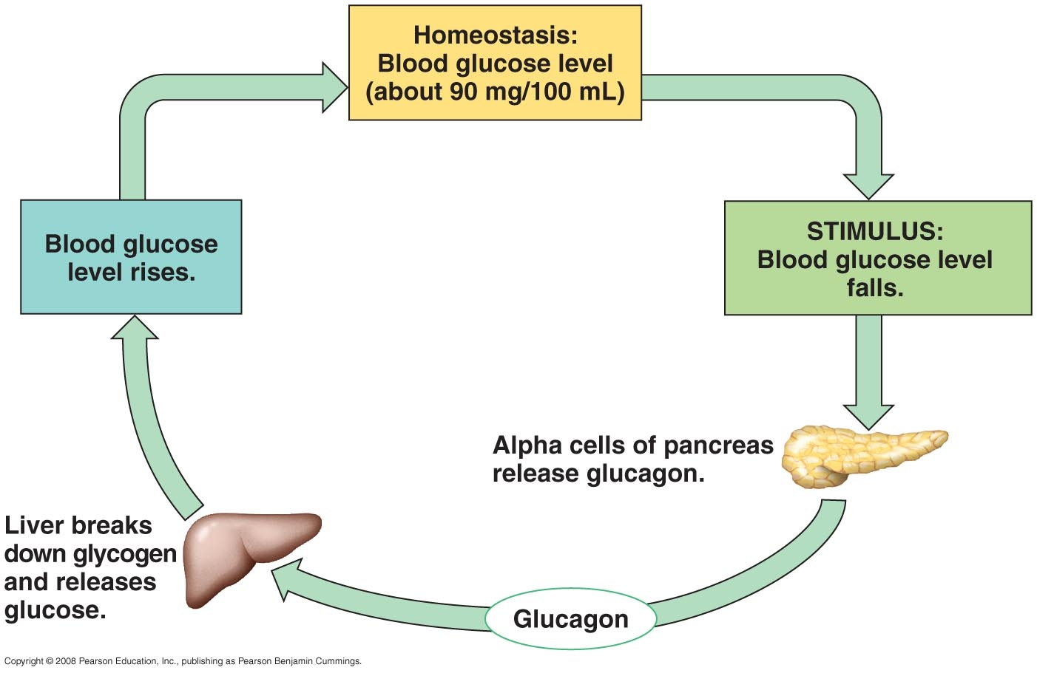

Set Point
Stimulus
Receptor
Integration Center
Effector
Response
Negative or Positive Feedback
Countercurrent Exchange
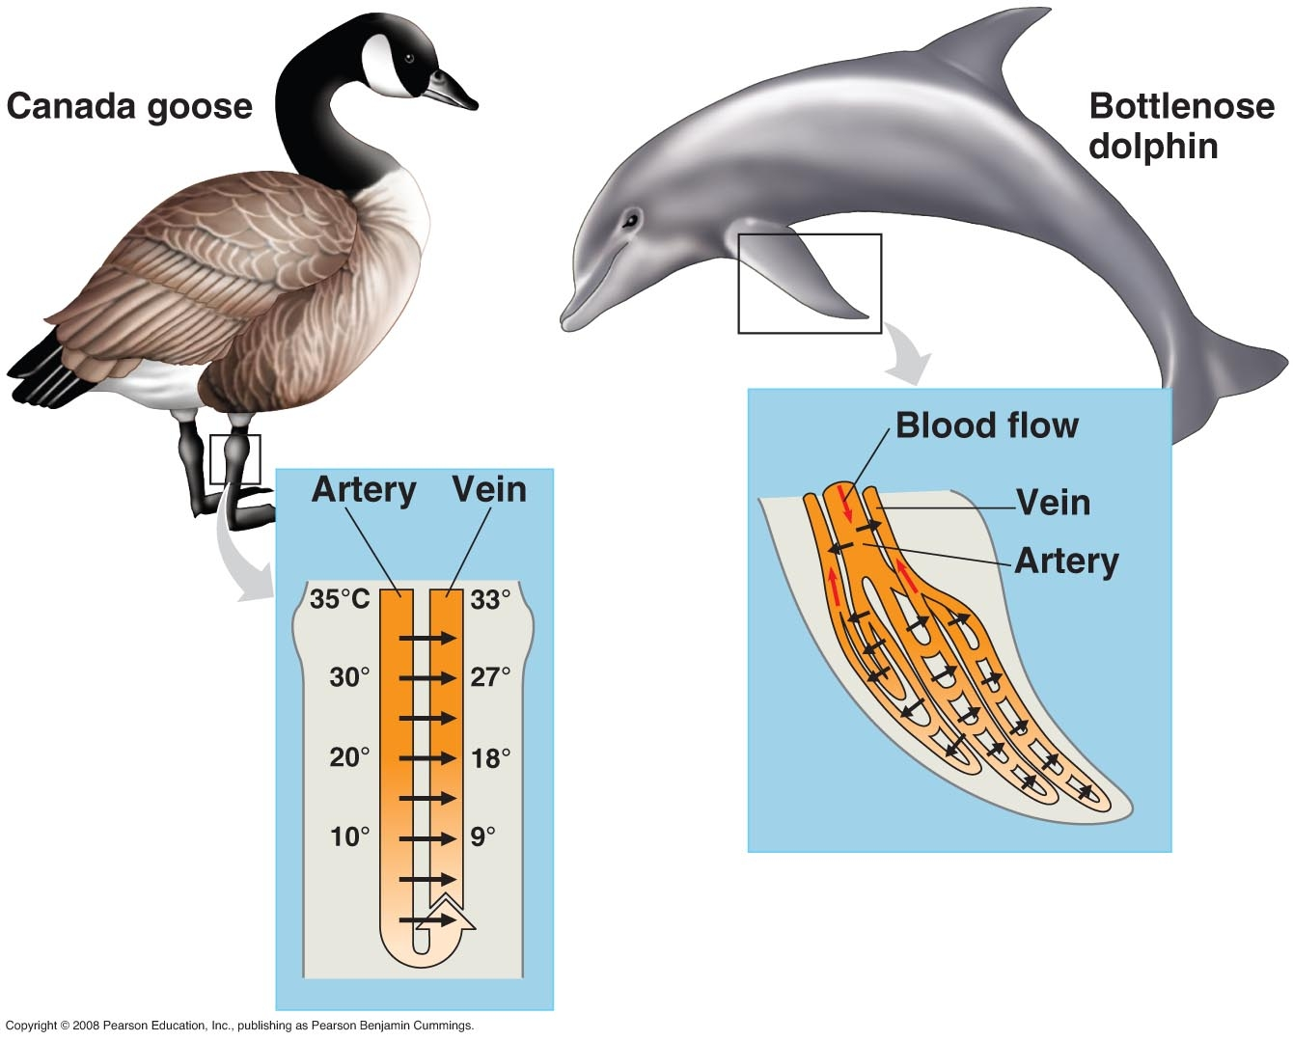

Venous Blood Arterial Blood

Draw Arrows that show fluid flow and direction of exchange.
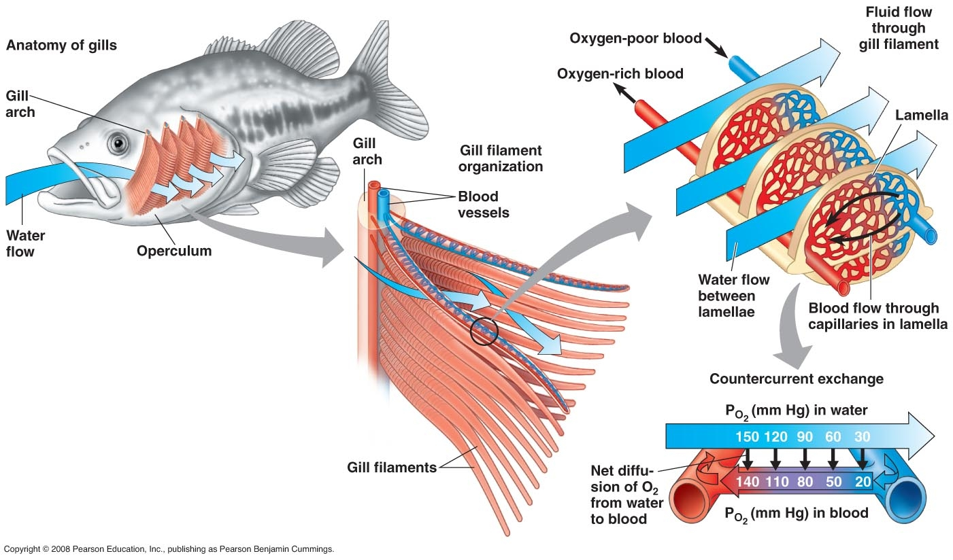

Water Flow Over Gills
Blood Flow Through Capillaries

Draw Arrows that show fluid flow and direction of exchange.

